**Node JS File modules**

Node.js include fs modules to access physical file system. The fs module is responsible for all asynchronous and synchronous file IO operations.

So when you want to use the File module first we have to load the module using the command as

var fs = require("fs");

**SimpleRead.js**

var fs = require("fs");

fs.readFile("demo.txt",(err,data)=>{

if(!err){

console.log(data.toString())

}else {

console.log(err.message);

}

})

**SimpleWrite.js**

var fs = require("fs");

var simpleMsg = "Welcome again to Node JS File System to Write the file";

fs.write("demo1.txt",simpleMsg, function(err){

if(!err){

console.log("File stored the information");

}

});

**AppendFileDemo.js**

var fs = require("fs");

var msg = "Welcome Again Again ";

fs.appendFile("demo2.txt",msg,function(err){

if(!err){

console.log("File stored the information")

}

})

**blockfile.js**

**var fs = require("fs");**

**var data = fs.readFileSync("test.txt");**

**console.log(data.toString());**

**console.log("Other Task");**

Output as

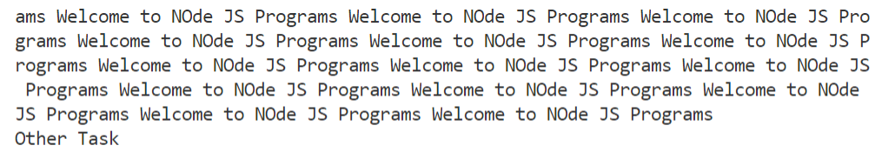

**nonblock.js**

var fs = require("fs")

fs.readFile( "test.txt", function( err, data ) {

console.log(data.toString());

});

console.log( "Do other tasks" );

**Output as**

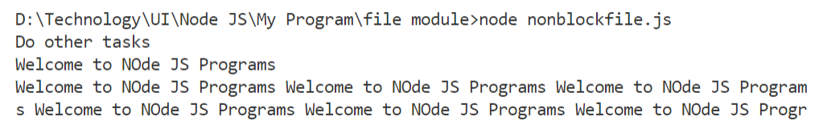

**json information stored in file**

**jsonInfoStore.js**

var fs = require("fs");

var empData = '{"id":100,"name":"Raj","salary":120000}';

var empJson = JSON.parse(empData);

var empObj =JSON.stringify(empJson);

console.log("Id is "+empJson.id);

console.log("Name is "+empJson.name);

console.log("Salary is "+empJson.salary);

fs.writeFile("empInfo.json",empObj,function(err){

if(!err){

console.log("Stored information");

}

})

The file created as

**empInfo.json**

**{"id":100,"name":"Raj","salary":120000}**

Read Emp info from the file

**jsonInfoRead.js**

**var fs = require("fs");**

**fs.readFile("empInfo.json",function(err,data){**

**if(!err){**

**console.log(data.toString());**

**var empInfo = data.toString();**

**var empJson = JSON.parse(empInfo);**

**console.log("id is "+empJson.id)**

**console.log("name is "+empJson.name)**

**console.log("salary is "+empJson.salary)**

**}**

**});**

After running this program

